使い勝手・使い回しの良いコミュニケーション活動の実例：
三浦 孝
目次
0. オーラル・インタラクション ２頁左

1. ギャップ活動
a. インフォメーション・ギャップ 2頁左
        - gap-filling活動
        - 道案内
        - インタビュー活動→実施レポート
        - ジグソー活動
        - 言葉当てクイズ←問題作成

b. オピニオン・ギャップ 2頁左
    - Likes and Dislikes
    - Values Clarification
    - 悩み相談に回答←悩み作成

c. イマジネーション・ギャップ 2頁右
    - こんな時君ならどうする？←お題作成
    - 夢の休日
    - picture description→相互評価

d. reasoning gap （思考のギャップ） 3頁左
- 教科書に質問しよう→他のグループの質問に答えよう

2. 発表活動
a. 名刺交換会→実施レポート 3頁左
b. Show and Tell / Picture Talk→聴衆メモ・感想の作成 3頁右
        - 私の大切なもの
        - 私の好きな有名人

c. mini presentation→相互評価 3頁右
        - 遠足候補地提案
        - 後輩に修学旅行の報告
        - 地域の隠れた名所
d. ポスター・セッション 3頁右
3. タスク活動 3頁右
e. 自己表現型タスク 3頁右
        - 言い換え作文
        - 言い換え会話
f. 問題解決型タスク→相互評価 4頁左
- picture differences
- こんな時どうするか？
- endingを考えよう
g. 立案型タスク→遠足候補地提案→相互評価 4頁右
h. 作品完成型タスク

4. 交渉活動 5頁左
i. strategic interaction→相互交流 5頁左
j.スケジュール調整ごっこ 5頁左
k.テキスト本文を改作して問題場面を作る 5頁左
5. 交流活動 5頁右
l. リレーノート 5頁右
m. I Know You 6頁左

6. discussion & debate 6頁左
n. 教科書に質問しよう→他のグループの質問に答えよう 6頁左
o. マイクロ・ディベート→相互評価 6頁左
p. 書いてディベート→事後感想 6頁右
q. 対案を考える→相互評価 7頁左
r. 投書に反論する→相互評価 7頁左
0. オーラル・インタラクション
2013年4月英語科教育法授業資料「Oral Introductionのシナリオ作成法」http://homepage3.nifty.com/tutormiura/

1. ギャップ活動
a. インフォメーション・ギャップ
        - 互いの持つ絵の違いを尋ねあう

        - 欠けた地図・表で相互に教え合う
(先生当てクイズ)
name | subject | favorite food | favorite star | hobbies
Mr. Ishida | math | ? | AKB48
? | P.E. | Chinese noodle | ? | fishing
Ms. Kimura | biology | ? |  | haiku

（ウ）インタビュー活動→実施レポート作成
（エ）ジグソー活動（『ヒューマンな英語授業がしたい』pp.171～178）
（オ）言葉当てクイズ←生徒も出題

b. オピニオン・ギャップ
（ア）Our Likes

（１）次の下線部に自分の好きなものを書き入れましょう。
1. I like ___________________________. [ ]
（好きな食べ物）
2. I like ___________________________.[ ]
（好きな飲み物）
3. I like ___________________________.[ ]
（好きな歌手）
4. I like ___________________________.[ ]
（好きな動物）
5. I like ___________________________.[ ]
(その他なんでも)
（２）互いに好きな物を伝えあいましょう。相手と自分が個のみが一緒なら[ ]に〇を記入しよう。

（イ）Values Clarification メインハンドアウトのp.7参照

（ウ）悩み相談に回答←生徒も相談文作成
Dear Sir/Madam,
Although I am twenty-one years old, I have never gone out with a man. My friends say, “Don’t worry,” but it is quite a serious problem for me!! All my female friends have gone out with guys, so they often talk about their love story. Whenever such conversation starts, naturally I cannot join it. I want a boyfriend, but I do not have any favorite person among my acquaintances. Some actually asked me out, but I have always refused. I may have too high ideal for guys, but I do not want to compromise. What should I do?
Loving Rabbit

c. イマジネーション・ギャップ
（ア）こんな時君ならどうする？←生徒もお題作成
What is Your Excuse? (二宮1996)
Your mom is angry. You want to calm her down. What would you say to her?

You are watching TV again. Have you finished your homework?

次の英文はみんなの作品です。いいと思うベスト３を選びましょう。
What is Your Excuse?
―Of course! Do you think I tell a lie? You must believe me. You may strike me if it was a lie.
―No, I haven’t. But please listen to my excuse. Homework isn’t important to my life. I don’t like to study. I want to watch TV. Don’t take my free time.
―I can do it in a minute. Today’s homework is as easy as no homework. Maybe when you ask me again, I’ll have already done it.
―Today you are beautiful, Mom.
―It’s my relaxing time. If I don’t relax at all, I can’t do it well.
―I don’t have any homework today. I have already studied hard at school. so I am very tired. Don’t say anything to me, please. If you say something to me, I’ll be sad and I’m going to die.

（イ）夢の休日/夢の学校
現実の制約を解き放ち、「もし何でも叶うとしたら、どのような5日間の休日を楽しみますか。体験談として語りましょう。」

（ウ）picture description→相互評価
多様に解釈できる絵を見せて、その絵のストーリーを創作させる。

d. reasoning gap （思考のギャップ）
- 教科書に質問しよう→他のグループの質問に答えよう

2. 発表活動
a. 名刺交換会→実施レポート

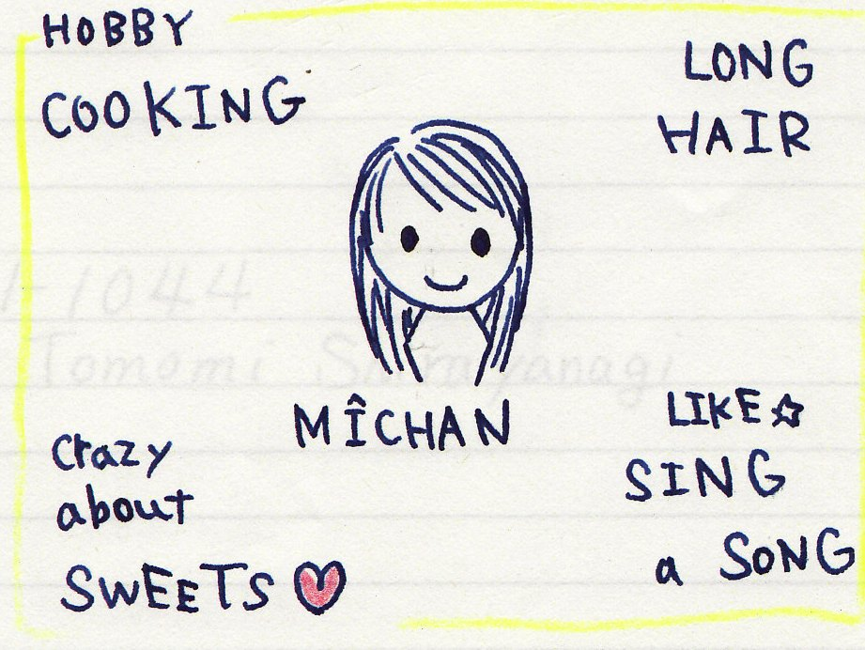

b. Show and Tell / Picture Talk→聴衆メモ・感想の作成
三浦2007年3月 「中高英語授業での継続的コミュニケション活動の運営法」http://homepage3.nifty.com/tutormiura/
        - 私の大切なもの
        - 私の好きな有名人

c. mini presentation→相互評価
        - 遠足候補地提案： 同上HP参照
        - 後輩に修学旅行の報告
        - 地域の隠れた名所
d. ポスター・セッション （『ヒューマンな英語授業がしたい』pp.130～133）

3. タスク活動

e. 自己表現型タスク
すること
国
言い換え作文
Someday, I want to go to ________ and ___________ there.

言い換え会話

２人でペアを組み、次の文の下線部に自分の希望を補って、対話を完成しよう。カッコ内からは、相手の話の内容にふさわしいフィードバックを選ぼう。
（１）最初に、文を作ろう。
A: What are you going to do in the summer vacation?
B: I am going to ________________________________.
How about you?
A: I am going to ________________________________.
B: That’s (wonderful/ exciting/ nice/ a hard job).
（２）原稿を見ずに２人でスラスラ言えるようになったら、先生のところでチェックを受けよう。
（３）チェックが済んだ他のペアと、この会話をしよう。その結果をインタビューシートに記入しよう。
＜インタビューレポートの例＞
Ｉ | am going to | visit my uncle in Kumamoto
Haruki | is going to | attend his swimming club
Kana | is going to | help her father’s farm
My teacher | is going to | go on a honeymoon trip in Las Vegas. (Really?)

f. 問題解決型タスク→相互評価
（ア）互いの持つ絵の違いを尋ねあう
（イ）こんな時どうするか？
You are traveling in downtown Tokyo. You’ve got lost and you were very hungry, so you went into a restaurant and ordered a dinner. (They have only expensive dinners on their menu.) Now that it is time to pay, and you realize that you have lost your wallet. It was an accident, and you never meant to steal a meal. How will you explain this to the waiter?

（ウ）物語やエッセーのendingを考えよう

g. 立案型タスク
遠足候補地提案→プレゼン→ベストプラン投票

h. 作品完成型タスク

６つの絵の中から４つを選び、並べてストーリーを作る。

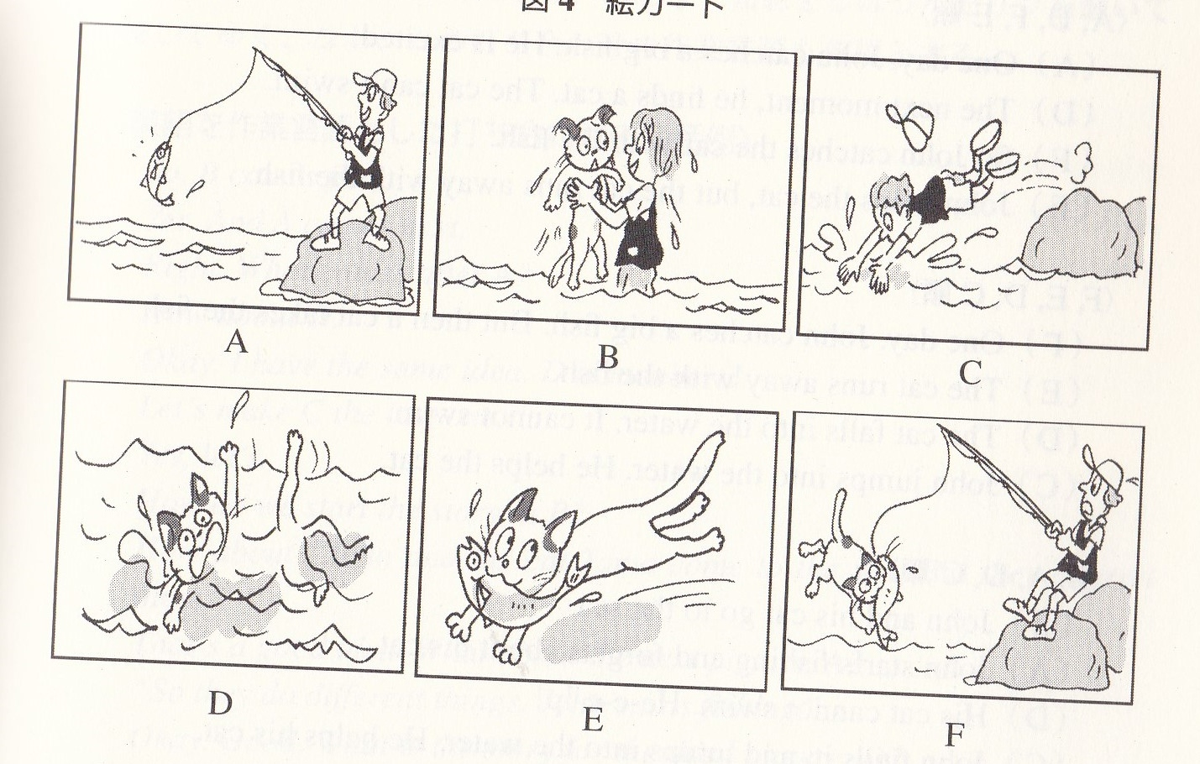

4. 交渉活動
i. Strategic Interaction(1-c, 2-f-イ)→相互交流

初級者用シナリオ例：Your host mother, Jeanette, makes sandwich for your lunch, and you appreciate it. However, it always contains some picked cucumber, which you really hate. So you cannot eat the sandwich. You are back at home, and your host mother will ask you how you liked the sandwich. How would you respond?
[ ] “Jeanette, thank you very much for the sandwich. I enjoyed it very much.”
[ ] “Jeanette, thank you very much for the sandwich. But please don’t put pickled cucumber in it.”
[ ] “Jeanette, thank you very much for the sandwich. Could I have something else for my lunch tomorrow?”
[ ] “Jeanette, I am having such a good time here. I am really glad I came. Only, …I don’t like pickled cucumber very much.”

Strategic Interactionの詳細は『ヒューマンな英語授業がしたい』pp.201～245参照）

j.スケジュール調整ごっこ
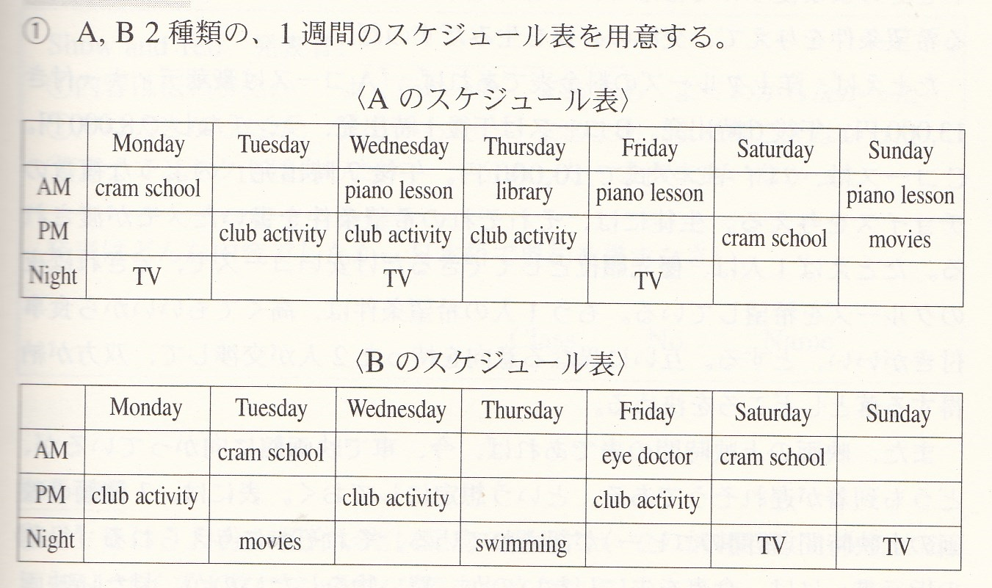

k.テキスト本文を改作して問題場面を作る
Strategic Interactionシナリオ
(下線部分は問題を発生させた箇所)
(Shop attendant) May I help you?
(Customer) Yes, please. I’m looking for some gloves.
(S) What color do you want?
(C ) Black.
(S) Black ones are over there.
(C ) Can I try them on?
(S) Sure.
(C ) These are a little too big.
(S) How about these?
(C) Fine. I’ll take them. How much are they?
(S) 17.95, please. Anything else?

(C) Yes, how much are these rings?
(S) 2.70 cents per each.
(C) Okay, I’ll take these five rings.
(S) A pair of gloves and five rings, …that’s 41.45 in total.

5. 交流活動
l. リレーノート
(1) ノートを３分の１に切って、各班（４人班）に１冊渡す。
(2) 各グループの中のリーダー的な生徒（モデルとなる文を書ける生徒）が、自分の考えやメッセージを書き、次の日に次の生徒に渡す（１日一人、家で書く）。約束事として次の５点を伝えておく。
①最初の生徒が始めたトピックは、一巡目の途中では変えない。
②賛成なのか、反対なのか、自分の意見を明らかにし、その根拠を述べる。
③友だちの書いた文で、いいと思ったものはどんどん真似るようにする。
④日本語やローマ字は厳禁。和英辞典を調べるのを面倒がらない。
⑤ １ページ（９行～１０行）にびっしりと書いて初めて評価の対象となる。
(3) 英語係が、ある決まった曜日（教師の授業時数の少ない日）の朝集めて、持ってくる。教師は、内容を見てコメントを書き、評価して、帰りの会までに返す。

m. I Know You
my favorite city, my favorite singer, my hobby などの中から各自１つ選んで、４人グループクラスメートにインタビューしてその人の情報を仕入れ、それを違う相手にレポートし（リプロダクション）、そのレポートを受けた人が最初の本人と対面して自由会話をする。
6. discussion & debate

n. 教科書に質問しよう→他のグループの質問に答えよう

o. マイクロ・ディベート→相互評価
身近な論点について3人がローテーションで短時間のディベートを行う。
セッション | 賛成派 | 反対派 | ジャッジ
1 | A | B | C
2 | B | C | A
3 | C | A | B
持ち時間：１セッションが10分
1. A(Yes) Constructive Speech 1.5 min.
2. B(No) Rebuttal(Attack) 1 min.
3. B(No) Constructive Speech 1.5 min.
4. A(Yes) Rebuttal (Attack) 1 min.
5. Free Debate 2 min.
6. C（Judge） Reflection time 3 min.（判定と講評）

p. 書いてディベート→事後感想

i) Our school should open a hamburger shop on the campus.
ii) A husband and a wife should have different surnames.
iii) Japan is a good country to live in.
iv) School lunch should be abolished.
v) We don’t need school uniforms.
vi) Every student should join a club activity.

意見の記入用に、Ａ３かＢ４の紙を配布し、1列目の生徒には命題i)、2列目にはii)というふうに命題を割り当てる。生徒は命題について自分の意見を書き、時間が来たら書いた紙を後ろの生徒にパスして、次々と別の命題について論述してゆく。

1) 1st writer: 割り当てられた命題について、賛成or 反対の立場を選んで論述し、５分後にはその紙を後ろの生徒に渡す。
2) 2nd writer: 受け取った紙には、1st writerの意見が書かれているので、それ に「反対」の立場で論述し、７分後にその紙を更に後ろの生徒に渡す。
3) 3rd writer: 受け取った紙には、2nd writerまでの意見が書かれているので、「1st writer に賛成・2nd writer に反対」の立場で論述し、７分後に紙を更に後ろの生徒に渡す。
4) 4th writer: 受け取った紙には、3rd writerまでの意見が書かれているので、「1st & 3rd writers に反対・2nd writer に賛成」の立場で論述し、７分後に紙を更に後ろの生徒に渡す。
5) 5th writer: 受け取った紙には、4th writerまでの意見が書かれているので、「1st & 3rd writers に賛成、2nd & 4th writersに反対」の立場で論述し、終了、紙を1st writer に戻す。
6) 1st writer: 返ってきた紙上ディベートを読み、「特に賛同する部分」「反論したい部分」に色マーカーで線を引き、感想を書いて提出。
詳細は三浦・中嶋・池岡（2006）pp.141-145を参照

q. 対案を考える→相互評価

 | against capital punishment | in favor of capital punishment
①死刑に対する諸外国の態度 | More and more advanced countries have abolished it.
②人権の観点から | No authority has the right to violate the right to live. | It is the murderers that deprive their victims of the right to live.
③社会正義の観点から |  | To protect the life of heinous criminals is against social justice.
④国連の死刑廃止条約への態度 | Japan should respect the treaty. | Each country can decide whether to ratify it or not.
⑤死刑が殺人を予防する効果 | There is no significant difference in the crime rate in the U.S. | Without death penalty, it would be difficult to prevent murders.
⑥無実の人を死刑にする危険 | There is the danger of hanging innocent people.

r. 投書に反論する →相互評価
Some Students Want Their Teacher to Hit Them.
These days, teachers are not allowed to hit students. If a teacher did that, the teacher would be penalized. However, I do not think all the copal punishments are wrong. On the contrary, I believe that teachers need to give corporal punishment for love according to occasions.
When we were children, we were hit or slapped by parents and teachers when we did wrong things. In those days, nobody called it violence. People understood that it was a sign of love and care. Even we children thanked for the punishment, because otherwise we might have become really bad people.
When I hear that all corporal punishment are punished as crimes, I worry how adults can correct children’s misbehavior when they don’t have ears to listen to. I am sure some students want their teachers to hit them.

The Important Thing to Change Students’ Mind
N.H.
I would like to respond to Shunsaku Igarashi’s article entitled ‘There are some students who want their teacher to hit them to change their mind’ on June 15. In his article, he says that at first he thought it bad for teachers to hit students, but he changed his idea after he knew that a student wanted teachers to do so. I disagree with him on several points.
First, in my opinion, it is very difficult to decide what is good violence and what is bad violence. For example, there was a male teacher who often hit his pupils when I was a schoolgirl. One day, a boy did his class job at the hallway. That was during the morning study period. So the teacher hit him as he wasn’t in the classroom at that time. I think this was bad violence because the teacher did not need to hit him. The teacher could have pointed out that the boy had to study in the classroom during the morning study period. In the classroom, there is only one teacher and there is no one who judges what is good violence and what is not. If teachers hit their students for unjust reasons, the students will not change their mind, but get hurt terribly.
Second, I think that teachers need to ask their students why they did bad things. Some students misbehave because they want their teacher to notice their pang. In such occasions, it is not good for teachers to try to change their mind by hitting. They may feel that their teachers ignore their feelings.
Last, from my point of view, it is meaningless that teachers hit their students from their emotion. That is because it is very important to establish reliable relationship between teachers and students in order to change students’ mind. If teachers hit their students with their egotistic emotion, they cannot be trusted by their students. Students can believe those teachers who understand their feelings. Also they can change their mind by themselves when they get to believe their teachers.
There may be some students who change their mind by being hit. But I believe that the most important thing for teachers is to contact with their students sincerely. Violence has only temporary effects. If teachers really want to change their students’ mind, they need plenty of time and big consideration for their students. (406 words)

