「教科書から発展させたコミュニケーション活動」
三浦 孝 （静岡大学名誉教授）
http://tutormiura.world.coocan.jp/

1. 教科書本文の延長線上に設ける基礎的コミュニケーション活動
[New Horizon English Course, 2006, Program 3-1から発展させた場合]
教科書本文
Yuki: Guess what! Next month I’m going to visit Sydney as an exchange student.
Mike: Oh, are you? You’re lucky. How long are you going to be away?
Yuki: For two weeks. I’m going to stay with a host family.
Mike: That’s great! You can talk with them in English every day.
Yuki: I hope so.

1.1 教科書本文の一部を応用した活動
（1）会話リレー
たとえばテキスト下線部を利用し、”Where are you going to visit on your honeymoon trip?”という質問を尋ねる。最前列の生徒に尋ね、生徒が”I am going to visit Las Vegas.”のように答えたら、後ろを向き、次の生徒に同じ質問を尋ねる。このようにして質問と答えをリレーし、最後尾の生徒は自分の答えを答えたら教師に同じ質問を尋ねる。教師がそれに答えたら完結する。

（2）言い換え会話
テキスト本文の表現を利用し、２人でペアを組み、下線部に自分の希望を補って、対話を完成しよう。相手の話の内容にふさわしいフィードバックも加えよう。
夏休みにやりそうなこと
travel in Kyoto
study at cram school
read Soseki’s novels
go camping in the forest
prepare for a Judo test
（ア）最初に、文を作ろう。
A: What are you going to do in the summer vacation?
B: I am going to ________________________________.
How about you?
A: I am going to ________________________________.
B: That’s (wonderful/ exciting/ nice/ a hard job).
（イ）原稿を見ずに２人でスラスラ言えるようになったら、先生のところでチェックを受けよう。
（ウ）チェックが済んだ他のペアと、この会話をしよう。その結果をインタビューシートに記入しよう。
（エ）＜インタビューレポートの例＞

Ｉ | am going to | visit my uncle in Kumamoto in the summer vacation.
Haruki | is going to | attend his swimming club in the summer vacation.
Kana | is going to | help her father’s farm in the summer vacation.
My teacher | is going to | go on a honeymoon trip in Las Vegas. (Really?)

（3）借文インタビュー
習った文型を使って、家庭学習で質問文を１つ作って覚えてくるよう指示しておく。次回の最初に、生徒がクラス中を歩いて自分の質問を尋ねて回る。時間は１０分程度とし、一定人数（たとえば８人）に尋ねたら着席することとする。
本時の学習事項‘be going to’を使って質問を作ってくる→次回の授業でクラスメートにインタビューして回る→事後レポートを書く。
（質問例）
生徒Ａ：What time are you going to go to bed tonight?
生徒Ｂ：What are you going to do next Sunday?
生徒Ｃ：Where are you going to live in the future?
(事後レポート例)
My question was “When are you going to do next Sunday” I asked eleven people. Five said “attend club activities.” Three said “relax at home.” Two said “not decided.” One said “go to an amusement park.”

1.2 教科書本文をふくらまそう
(1) 会話にセリフを追加しよう
YukiとMikeの会話は、このあとどう展開するだろうか？下記のシナリオの最後に、あと２ターン会話を続けよう。
＜作品例（下線部が、生徒が追加した文章）＞
Mike: That’s great! You can talk with them in English every day.
Yuki: I hope so.
＿But I cannot speak English very well.
Mike: Don’t worry You speak good English.
Yuki: Do you think so? Oh, I’m glad to hear that.

(2) 教科書に対して質問し発言しよう
Step 1: YukiとMikeの会話が、もっと具体的になるように、教科書の行間に質問や発言を入れてみよう。出来上がったら隣の人と用紙を交換して、質問に答えてみよう。
＜作品例：(下線部が追加された質問や発言)＞
Yuki: Guess what! Next month I’m going to visit Sydney as an exchange student.
Mike: Oh, are you? You’re lucky. How long are you going to be away?
Are you going there alone? How long does it take from Japan? Are you leaving from Shizuoka Airport or Chubu Airport?
Yuki: For two weeks. I’m going to stay with a host family.
Mike, did you visit Australia before? What is the season now in Australia? Do I need some winter clothes?

Mike: That’s great! You can talk with them in English every day. How many family
members do they have? Do you have any host sisters or brothers?
Yuki: I hope so. I will write E-mails to you.

２．教科書のレッスンの延長線上に設けたいディスカッション的活動
（本発表での「ディスカッション」の定義： 「自分たちの質問、感想や考えを口頭・筆頭で表現し交流すること」）

2.1 取り掛かりはシンプルに、”Which of these three units do you like best? Why do you think so?”で始める。
2.2教科書に関連質問を出しあう活動
⇒グループで作成し、隣のグループと交換して答える活動へも発展可能
（例１）中学教科書
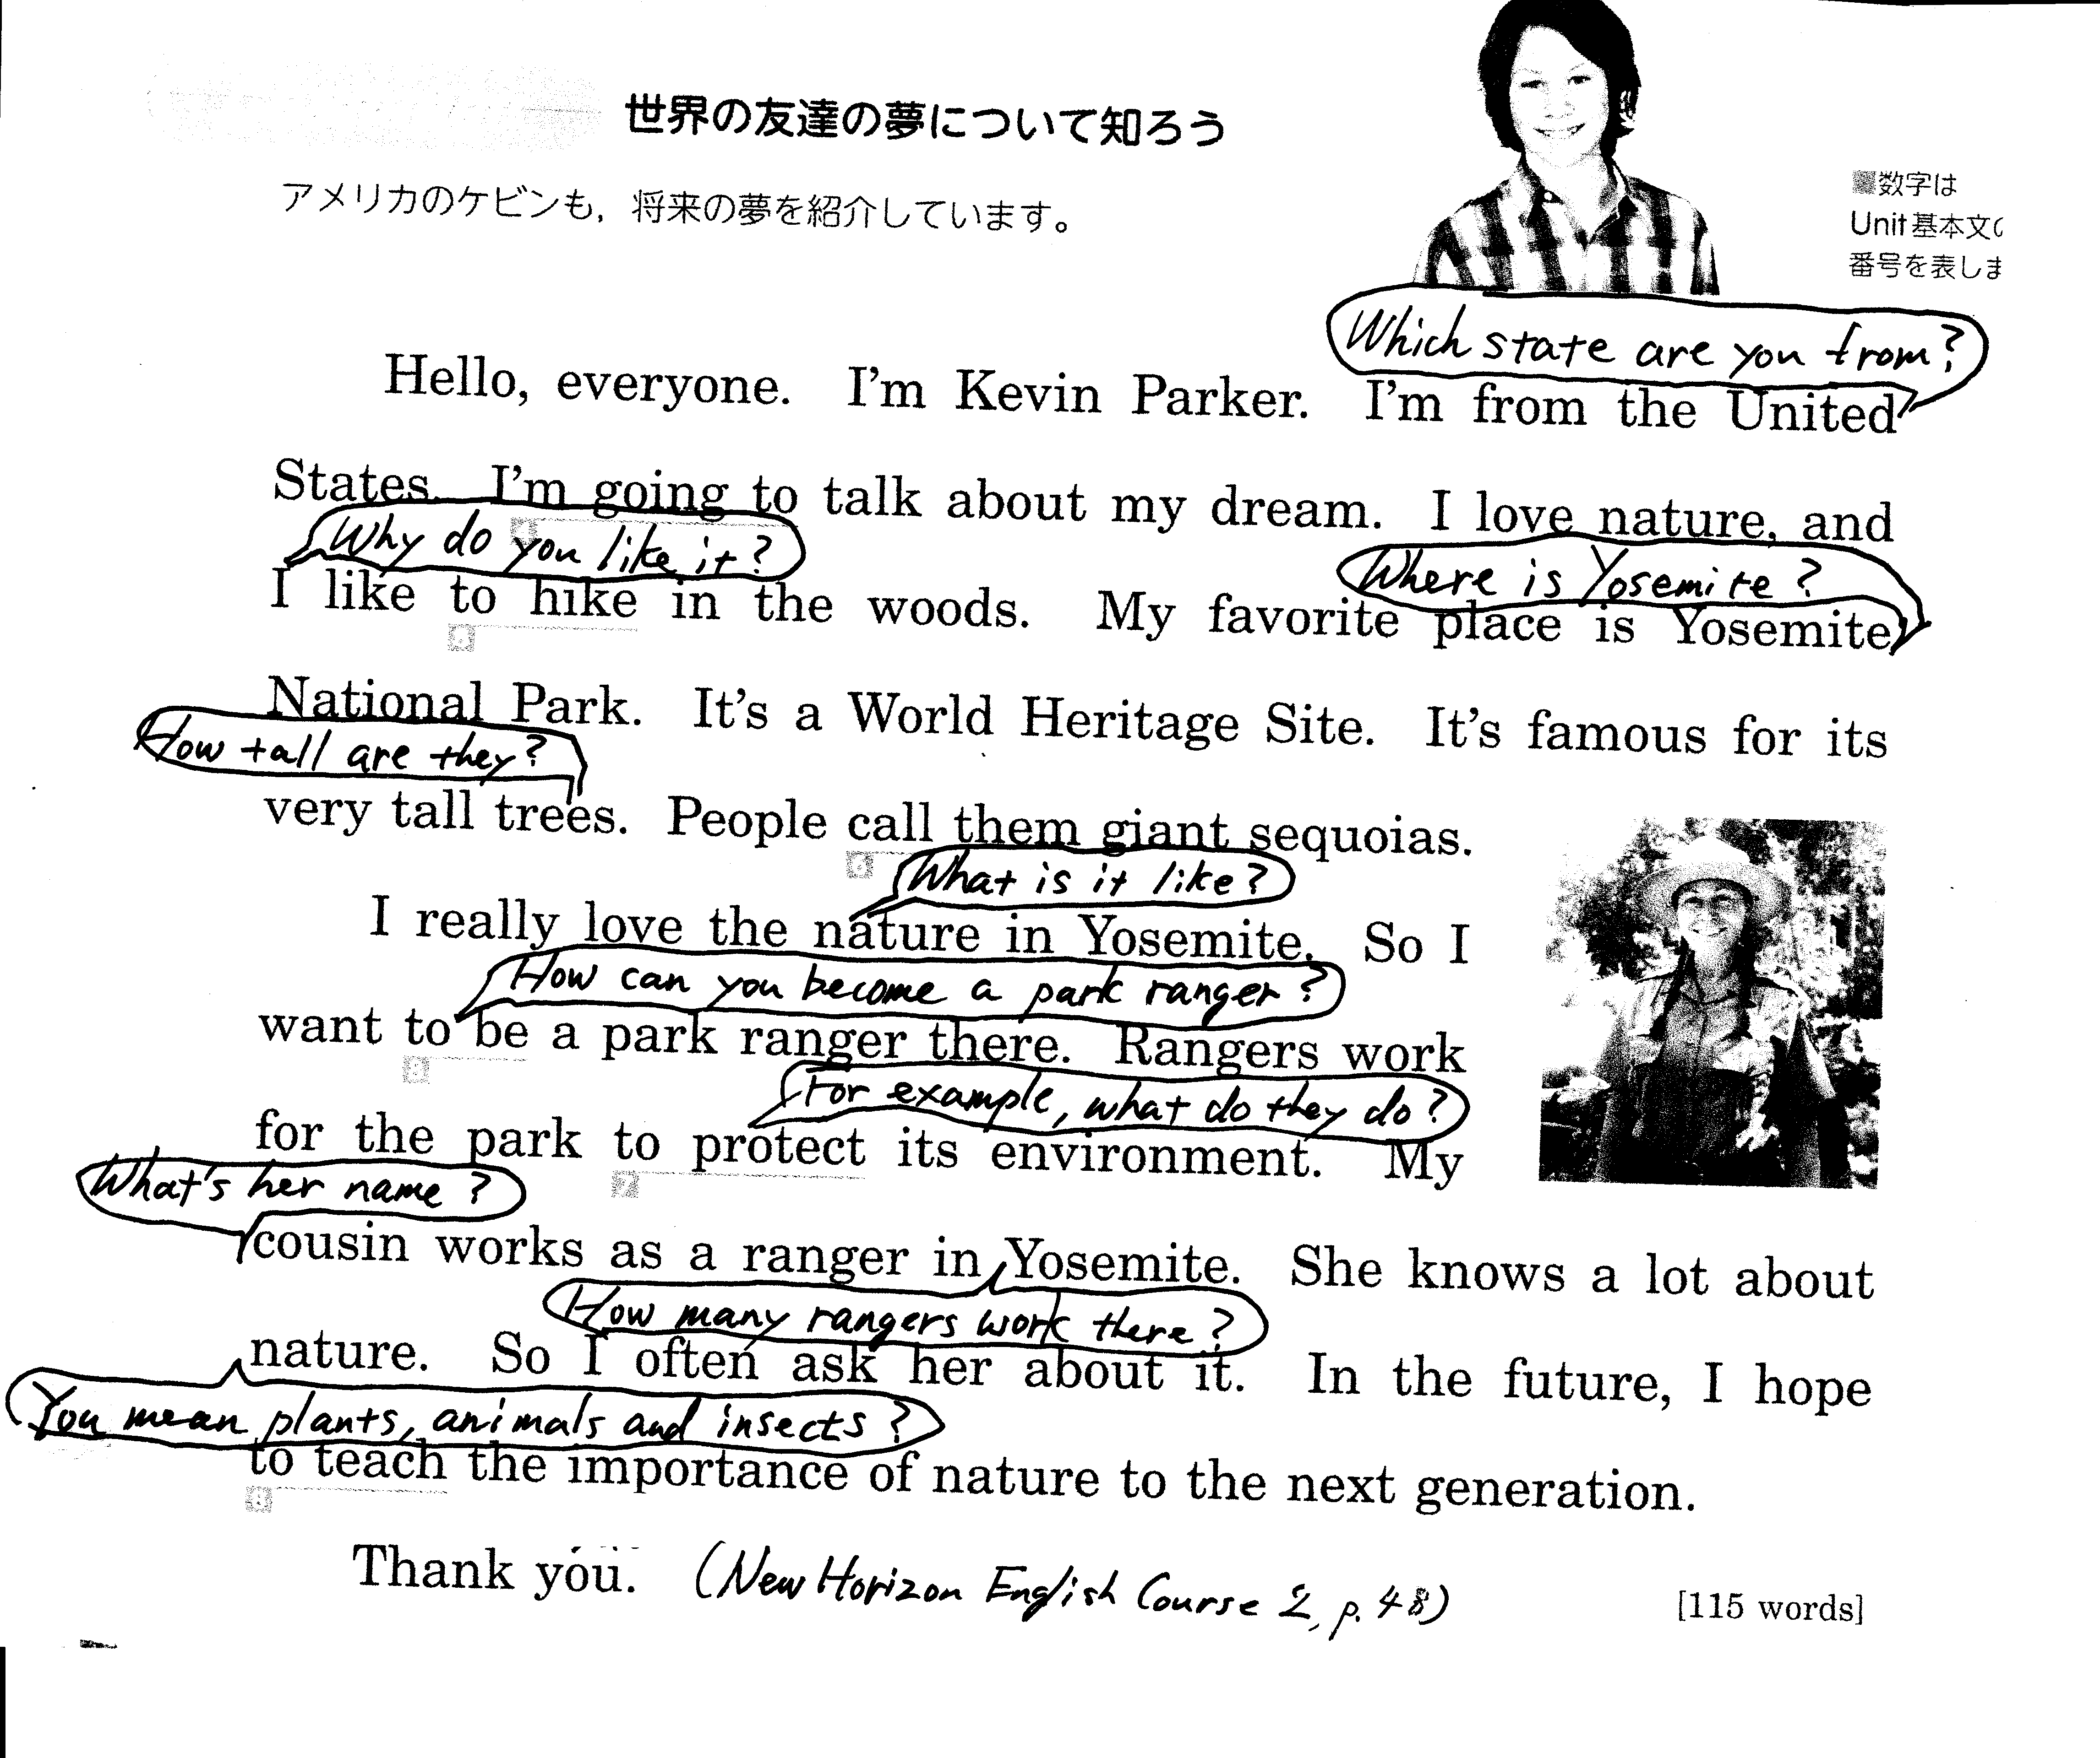

自分がpresentationのaudienceとしてこれを聞いているとしたら、どんな質問が湧いてくるか、と考える。

（例２）高校教科書
Eat grains. They give you carbohydrates for energy, plus vitamins, minerals and fiber. Besides, they taste good! Try whole-wheat bread and rye. Spaghetti and rice are also in the grain group. Don’t forget fruits and vegetables. Bananas, strawberries and melons are some great tasting fruits. Try vegetables raw, on a sandwich or in a salad. In fact, cooked vegetables lose many of their vitamins. (高等学校検定教科書New Stream English Course II, p.22)

Q1. Why do you recommend whole wheat and rye bread? （主張の根拠を問う）
Q2. Is it always true that raw vegetables are better than cooked ones?（栄養学の知見との整合性を問う）

2.3 教科書（対話文）に創作して付け足す活動
（例３．中学教科書）Alex（カナダからの留学生）とDeepa（インドからの留学生）の対話に、あと2行付け足しなさい。(どちらの発言でもかまわない)

Alex. Deepa, where did you go on Career Day?
Deepa. I went to an Italian restaurant.
I want to be a chef.
Alex. Wow. How was it?
Deepa. It was interesting, but I got tired.
I tried to learn the whole menu, but I couldn’t. （New Horizon English Course 2, p.34）
______. ______________________________________________
______. ______________________________________________

作品例：
Alex. In what way was it interesting?
Deepa. First, Italian cooking was very different from Indian cooking. They use a lot of olive oil.

2.4 教科書（ストーリー）に、「君が主人公ならどうする？」を問う活動
（例４．高校読物The Gift of the Magiに関して）「あなたは，Jim/Dellaです。明日はクリスマスなのにお金がありません。でも，愛するDella/Jimにプレゼントを贈りたいと思っています。あなたならどうしましたか？」
高専2年生作品の抜粋
If I were Jim,
      - I would do the same thing as Jim.
      - I would cook dinner for Della.
      - I would sing a love song for her.
      - I would buy a playing card and play magic to her.
      - I would take her to the top of the highest building at the time, show the beautiful night view of NYC and tell her my love.
      - I would make a wool hat for her and give it.
      - I would write a letter this year and save a money for the next Christmas.
（種村、2016、pp.240-241 ）
2.5 教科書（ストーリーや論説文）に、「君はどちらに賛成するか？」を問う活動
（例５．高校読物The Gift of the Magiに関して）「Jimは給料が安く，Dellaは無職，収入の40%はぼろアパートの家賃に消え，毎日赤字の生活。でも，二人は愛し合っている。あなたは，JimとDellaのように暮らしたいと思いますか？そして，それはなぜですか？」

高専2年生作品の抜粋
I would like to live like Jim and Della, because….
・they look happy.
・if we love each other, we can get over all things.
・I think the rich and the happiness are not equal. There is more important thing than money. So, I want to be with No.1 partner together.
・if we love each other, I can feel happy. But I think that it is the best. There are both money and love.
I would not like to live like Jim and Della, because
・without money I can’t make Della happy.
・we will be in trouble about money. So I will make an effort to find a job and have a good life with my lover.
・I want to have a child and spend a happy time. So we need money to bring up our child.
・I don’ t want to get married until I can make living by myself.
（種村、2016、pp.241-242 ）

2.6 教科書（会話）を教師が改作して、発展的タスクとする。
（例６．中学教科書）買い物の会話 (New Horizon English Course 2 pp.110-111)
店員 Hello. May I help you?
エリカ Yes, please. I like these jackets.
店員 We have more in the back. What color are you looking for?
エリカ Something bright.
店員 How about this orange one?
エリカ Oh, that’s cool. But it’s too big for me.
店員 Shall I show you a smaller one?
エリカ Yes, please. Oh, this is nice. How much is it?
店員 It’s sixty dollars.
発展的シナリオに改作
エリカ OK. I’ll take it.
エリカ And how much are these rings?
店員 Seven dollars for each.
エリカ I’ll take these four.
店員 Ninety-eight in total.
エリカ ＿(これを生徒が考える)＿＿＿＿＿＿＿

生徒作品をクラスでシェアア

2.7 生徒が教材読後に関連質問を作り、クラスメートにインタビューし、結果をレポートする方法

(ア)教科書の原文
教科書原文
“Help yourself” (“tsumetai” and “cold”)
A college professor in Japan told me that the most frequent complaint of Japanese students who took part in his college’s home-stay program in America, was that their American host family was “tsumetai”, or cold. When asked to explain, the students said that their host parents would tell them that they would cook and serve their dinners, but that everyone in the family fixed their own breakfasts and snacks. Then they would point to the refrigerator and say, “Help yourself.” This
invariably shocked the Japanese students. “How could I possibly help myself to food from their refrigerator? And even worse, how could they say that to me on the very first day!”
Interestingly, a Japanese-language teacher at a high school in Hawaii told the same professor that the most frequent complaint of American students who took part in her school’s home-stay program in Japan, was that their Japanese host family was “cold and unfriendly.” When asked to explain, the students said that the host mother would always insist on serving them everything. “It made me feel very uncomfortable. I couldn’t even get myself a glass of juice from the refrigerator. And this went on to the very last day!”
(Sakamoto & Sakamoto, Polite Fictions in Collision, p. 16)

学生のインタビューレポート
Interview Report
Written by M.O
1. Interview Question:
(1) If you were a home-stay student, which would you prefer, to be treated as a family member or a special guest?
(2) If your host family always said, “Help yourself” to you, how would you feel?
(3) How would you want to treat your foreign guest when you take on a home-stay student in your family?

2. Interview Results:
I asked these questions to 5 classmates, and got the following answers.

Respondents | Sex | (1)want to be treated as a | (2)reaction to “Help yourself” | (3)want to treat my guest as a
Miyuki | F | special guest | “tsumetai” | special guest
Yuki | F | family | natural | special guest
Sayuri | F | special guest | not kind | special guest
Yumi | F | family | no problem | special guest
Aya | F | family | natural | special guest

3. Discussion
Although I asked these questions to only five students this time, I was surprised that some students want to be treated as a family member and do not interpret “Help yourself” as “tsumetai”. Next time, I would like to ask these questions to many students and compare their answers.

こうしてこの学生は、教科書に書かれていた内容が今日の日本人（少なくとも大学生）には必ずしも該当しないことを指摘するに至った。

2.8 proofなく混入している前提を突き止める活動
文章の中に埋め込まれた、証明されていない前提によって、結論が誘導されていることをつきとめる活動
（例７ 大学英語教科書）

教科書本文
Don’t Work Too Hard.
In Japan, when someone is about to take a test, or enter a sports event, or start a new job, it is customary for others to say to him, “Gambatte!”, which translates roughly as “Work hard!”, or “Do your best!” This would sound very strange in English. The usual English expression would be just the opposite: “Don’t work too hard,” or “Take it easy.” Americans would assume that anyone in such a situation would already be keyed up and wouldn’t need to be told to work hard. Instead, he would need to be reminded to relax. （Sakamoto & Sakamoto, 16）
予想される意見
I do not think this translation accurately translates Japanese mind. By saying “Gambatte”, we do not always mean “Work harder,” but rather show our affiliation to the addressee. Japanese “Gambatte” could be better translated as “I am on your side” or “Good luck.”
(論述の前提として使われている”gambatte”の定義に疑問を呈している。)

2.9 高校教科書に関連質問を出しあう活動の追加例
ディベート教材として作られた下記の教材は、ディベートとして十分に成立しているとは言えない。それを素材として利用し、生徒が関連質問を考える活動へと高める。

単元名‘Is life with modern technology better than the simple life we had in the past?’

教科書本文：
The affirmative side’s opinion:
Thanks to technological advances, our life has become much better than it was in the past. Technology has saved us a lot of time and our daily life itself has become much more convenient than it was before. Household appliances, such as vacuum cleaners and washing machines, have enabled us to do housework easily and in a much shorter time. The Internet enables us to get the latest information in a moment. This can help us live our life more wisely than in the past. Furthermore, modern technology has enriched our life by giving us various new forms of entertainment. Considering these three factors, it is clear that our life is much better now than it was in the past.
Q3
Q2
Q1
Q3
Q2
The negative side's- opinion:
Q4
Life in the past used to be much better than it is now. The Internet, which we enjoy now, is of course convenient, but people depend too much on electronic communication and ignore the importance of face-to-face communication. In the past, the pace of life was slower and we felt less stress, unlike the fast-moving world we live in today. Moreover, life was much healthier with a cleaner environment and less polluted food and water. Life for all living creatures on Earth was healthier. Considering these factors, it is clear that the life we had in the past was much better than the life we have now. (霜崎實、他 (2013) Crown English Communication II 三省堂 p.96、筆者下線)
Q5

考えられる質問例
Q1. What do you mean by ‘our’? Do you mean Japanese people, people in advanced countries, or the whole people on the earth?
Q2. Is this always true? Modern technology has endangered our life, such as nuclear weapons, nuclear accidents, and mass-killing in wars.
Q3. Could you give some examples of ‘new forms of entertainment’?
Q4. Which age do you refer to by ‘life in the past’? In the 19th century, before Industrial Revolution, or in the Stone Age?
Q5. You have only considered the Internet and pollution. What about other important factors such as the development of medicine and public hygiene, supply of food and water, and disaster prevention, for example

2.10 より充実した教材へと生徒が改作する活動
ディベート教材として作られた上記の教材では、ディベートが十分に成立しているとは言えない。それを素材として、生徒がよりディベートらしい内容へと高める活動。

（次頁へ）

points of argument |  | affirmative-side | negative-side
Modern technology | 1 | saves our time | makes the world too busy
Modern technology | 2 | makes life more convenient | makes life more stressful
Modern technology | 3 | enriches life with new forms of entertainment
Modern technology | 4 |  | pollutes environment (food, water, etc.)
Modern technology | 5 |  | makes living creatures unhealthy
The Internet | 6 | helps us get latest information
The Internet | 7 | makes our life wiser
The Internet | 8 |  | makes people dependent on electronic communication
The Internet | 9 |  | makes us ignore face- to-face communication

let students create and fill missing parts

group sharing

class sharing

結論：こうして教科書は生徒の力でもっと面白くなる。

引用文献リスト
安藤昭一（他）(2008) 高等学校検定教科書New Stream English Course II. 増進堂
笠島準一（他）(2016) . 中学校英語検定教科書New Horizon English Course 2. 東京書籍
種村綾子 (2016). 「『Trinity English Series Book 1』を使った高専での授業」『高校英語授業を知的にしたい』. 研究社
三浦・亘理・山本・柳田（編著） (2016). 『高校英語授業を知的にしたい』. 研究社
Sakamoto, N. and S. Sakamoto. (2004). Polite Fictions in Collision. 金星堂
霜崎實（他） (2013). 高等学校英語検定教科書Crown English Communication II. 三省堂

